

SIMATS ENGINEERING

Saveetha Institute of Medical and Technical Sciences Chennai- 602105

Student Name: Manoj M Reg No.:192511060
Course Code: UBA0974 Slot: C
Course Name: Programming in Java for Event Handling
Course Faculty: Dr. A.Mohan
Project Title: Print Ease - A Campus Quick-Commerce Platform for On-Demand Academic Printing
Module Photographs:
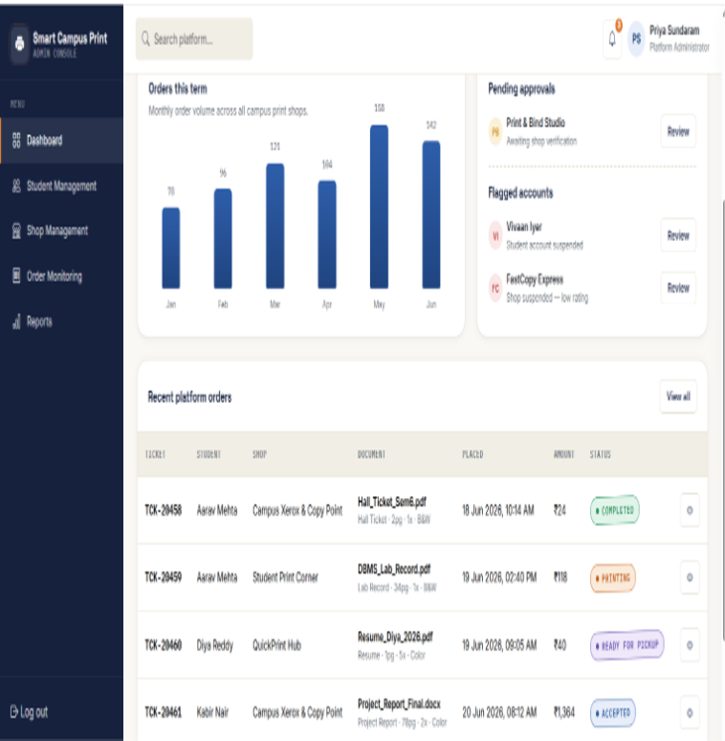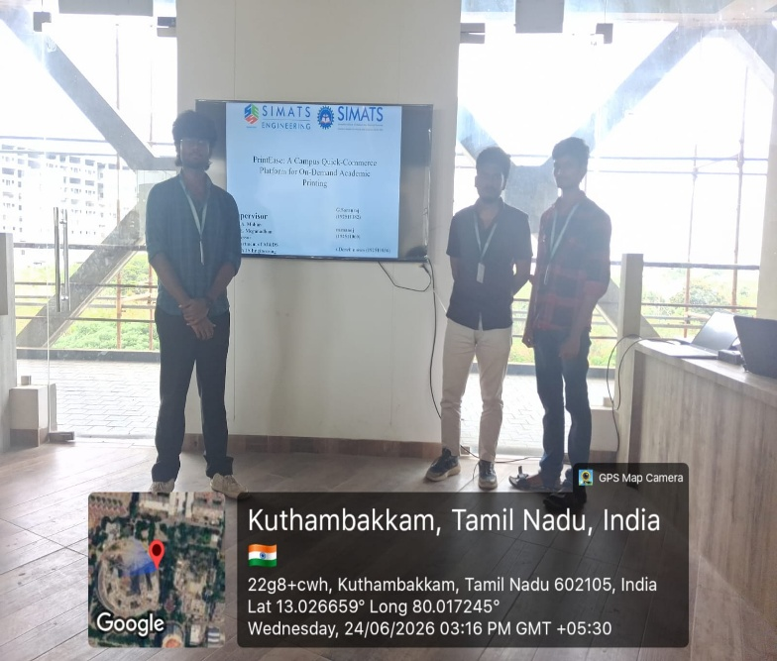
Project Description:
PrintEase - The Smart Campus Print Management System is a Java-based desktop application developed using the Abstract Window Toolkit (AWT) to simplify and digitize print-order management within a college campus. The system connects students, print shop owners, and administrators through a centralized platform. Students can register, place print orders, specify printing requirements, track order status, and view pricing details. Shop owners can manage orders and update progress, while administrators oversee system operations. The application improves efficiency, reduces waiting time, minimizes communication errors, and enhances user convenience. Developed using object-oriented principles and AWT components, SCPMS provides a reliable, user-friendly, and scalable solution for campus printing services.

Student Signature Guide Signature

